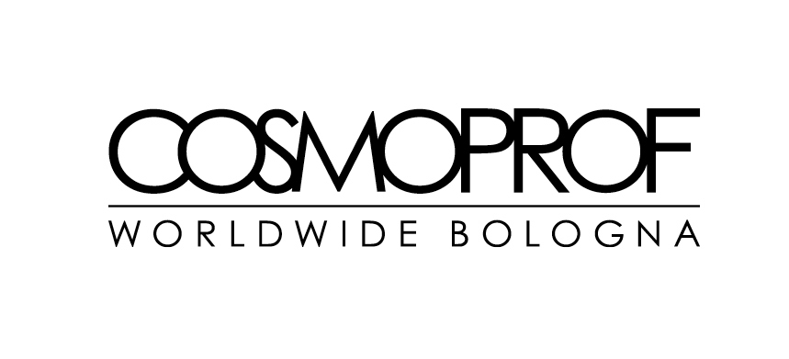

FROM AESTHETIC PERFECTION TO HOLISTIC WELLBEING: THE NEW PARADIGM OF THE COSMETIC INDUSTRY

June 2023 - The cosmetics industry is a sector in constant growth, and at the same time in constant evolution. Brands and retailers are dealing with a new approach to beauty and self-care: thanks to social and economic uncertainties as well as new ways of interacting between individuals consumers are less influenced by a concept of beauty as aesthetic perfection. Rejuvenating at all costs and conforming to stereotypes are no longer the main objectives for choosing a beauty product. Proposals and brands with a holistic approach are gaining value, with treatments that increase psycho-physical wellbeing, and consequently self-esteem and self-acceptance.

The wellness industry is increasingly connected to cosmetics as a strategic trend for the overall growth of the sector. As highlighted in the 2023-2027 report released by the strategic consultancy multinational McKinsey & Company, the wellness sector is currently worth 1,5 trillion USD, with an annual growth forecast up to 2027 that can reach 10%. The United States is the greatest market with a turnover of 450 billion USD in 2022. Second is China with a turnover between 350 and 400 billion USA. In Europe the value is lower, equal to about 130 billion USD, but with important signs of growth.
The attention to well-being increases the birth and sales volumes of new categories of beauty products, with innovative ingredients, spa treatments and proposals studied for topics hitherto little considered such as the quality of sleep, or even real taboos such as sexual wellness and menopause.

The new dimension of beauty was the subject of a round table at Cosmoprof Worldwide Bologna, "Beauty: A safe space to connect with oneself and the world". The talk, which took place on Thursday 16 March as part of the CosmoTalks calendar, was organized in collaboration with NellyRodi, a consultancy agency for corporate strategy and creativity, with the moderation of Kacey Culliney, Editor of CosmeticsDesign-Europe, a magazine of the William Reed Business Media France group.

During the meeting, the current role of cosmetics emerged as a comfortable and safe space, where everyone can find solutions to improve their personal balance, accepting emotions and fragility. “Wellness is a central theme, which offers new business opportunities for companies in the beauty sector. Brands can accompany consumers on a journey through self-acceptance at all stages of life, operating as a life coach and helping consumers express themselves in a safe space", highlighted Chloe Arjona, Senior Consulting Manager specializing in Beauty by NellyRodi.

“We are experiencing a gradual transformation: a growing interest in the theme of wellness has already arisen in recent years. The pandemic has accelerated this evolution, and today we are witnessing the transition from wellness to wellbeing”, underlined Sandrine Henrie, Co-conceptor of Ulé Beauty during the round table. “Mental wellbeing is very important for consumers; they follow brands that share common values, traditions and habits in a credible and authentic way. Communities are to share suggestions and difficulties among friends”.

Mayia Alleaume, Beauty Expert & Founder of Sentara Holistic, turned the spotlight on the new consumer approach to beauty and personal care products. “Until recently, consumers wanted to cover up their true face and body; today they seek the truth, they want to feel self-confident and regain self-esteem, improving their wellbeing. It is a more spiritual approach to cosmetic products, with easy treatments and rituals that help you feel better. There are no solutions suitable for everyone, but spaces where everyone can find the best product, treatment or activity".

“The cosmetics industry has an important responsibility towards the younger generations, it is therefore essential to convey realistic expectations, to stimulate consumers on a path of self-acceptance and wellbeing. According to some market research, in the United States alone over 30,000 young people under 18 undergo cosmetic surgery. It is a real emergency, and the cosmetics industry cannot remain indifferent", denounced Inge Theron, Founder and Creative Director of Facegym. “Cosmetics often place unrealistic expectations on men and women. There have been big changes, today we are increasingly seeing the covers of the most prestigious magazines with people of all sizes and skin colours. It is a phase of exciting changes, and there are many opportunities for brands with a creative, innovative and authentic approach. We must continue on this path."
Attention to wellbeing and wellness leads to new players in the dialogue between consumers and brands. First of all, new intermediators and "influencers" will be holistic operators as well as dermatologists, biologists and scientific professionals , who will become the most renowned ambassadors.
Distribution channels and physical spaces are also changing. The areas dedicated to wellness within the main global retailers are growing, as are the activities involving spas, hotels and clinics in rituals and wellness treatments for body and mind, with high-level collaborations with global brands.
The offers and services for consumers are also increasing, with the search for new professionals. For example, massage is an ever-growing treatment. "At the World Massage Meeting during Cosmoprof Bologna 2023 we addressed these issues, trying to add skills in a sector that is experiencing a particular historical moment: on the one hand the great increase in market requests and on the other overwhelming information " says Manuela Ravasio, Creator and Trainer of the Integro Method and training guide of the World Massage Meeting, a Cosmoprof event dedicated to body techniques. "Massage is undoubtedly one of the most profitable techniques for psycho-physical balance, the space where body and mind have the opportunity to communicate, where people can access their own "profound knowledge". Touch brings beauty to the body and lightness to the mind", continues Ravasio.
Ivan Conversano, Founder and President of EMA - European Massage Association, was official partner for World Massage Meeting. “At Cosmoprof Worldwide Bologna 2023 we were able to give the right meaning to the word “massage”, a manual practice that allows human beings maintaining health, seeking well-being and psycho-physical relaxation. The massage highlights the importance of touch, the first of the 5 senses we develop in the maternal womb. Through touch we listened to the world around us, the vibrations of the maternal belly walls when she was happy, sad, anxious, joyful. We made those emotions our own in an empathic experience. Thanks to massage we have a total immersive awareness, aimed at reducing tensions, anxieties, worries, decreasing as much as possible the distance between our body and our mind”, underlines Conversano.
Wellness and holistic cosmetics will be strategic issues for future market development. For further information and updates, please visit www.cosmoprof.com

